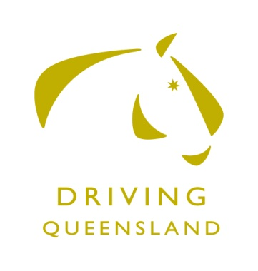 | 2020 – 2021 MEMBERSHIP FORM  1 September 2020 to 31 August 2021  Queensland Competition Carriage Driving Inc.  440 Linthorpe Valley Road, SOUTHBROOK Q 4363  Website: www.queenslandcompetitioncarriagedriving.com  Email:qldcompetitioncarriagedriving@gmail.com  This form becomes a TAX INVOICE on payment  ABN: 79 560 017 175
Surname: _______________________________________Given Name:_____________________________

Address: _______________________________________________________________________________

Town: __________________________________________ Post Code: ______________________________

Telephone:______________________________________ Mobile: ________________________________

Email:___________________________________________ Date of Birth: __________________________

Membership Categories: (Please indicate category) Single and Junior membership will entitle members to free lunch and refreshments on designated Club Days.
- Single Adult |  | $50.00
- Junior ( Under 18 years of age) |  | $40.00
MEMBERSHIP AGREEMENT – I hereby apply for membership/ renewal of membership of Queensland Competition Carriage Driving Inc. In doing so, I agree to be bound by the Constitution, Rules, Regulations and By Laws of Queensland Competition Carriage Driving Inc.
Release of Waiver of Liability
This release and waiver applies to all Equestrian Queensland endorsed activities and MUST be signed prior to membership being processed
In consideration for being permitted to participate in any way in horse sport activities, I, the undersigned, understand, acknowledge and accept that:
Horse sports are a dangerous activity and horses can act in a sudden and unpredictable (changeable) way, especially if frightened or hurt.
There is a significant risk that serious INJURY or DEATH may result from horse sport activities.
I understand and acknowledge the dangers associated with the consumption of alcohol or any mind altering drugs and agree not to drink alcohol or take drugs prohibited by law before or during any horse sports activities.
I agree to follow the directions of any event organiser or official and that any misconduct or refusal by me to follow any direction of any organiser or official can result in the CANCELLATION of my participation in the activities and my immediate removal from my horse NO MATTER where that may occur.
I agree to wear an approved helmet at all times whilst participating in the sport where this is required under the relevant EA and FEI rules and regulations.
I have had sufficient opportunity to read this Dangerous Activity Acknowledgement and fully understand its terms and sign it freely and voluntarily.
Signature of Member......................................................................................Date……………………….

For Participants of Minority Age (Under Age 18):
Parent / Guardian Name……………………………………………………………………. This is to certify that I, as a parent/guardian with legal responsibility for this participant, acknowledge, understand & accept ALL OF THE ABOVE & consent & agree to my minor child's involvement or participation in horse sport activities. I also agree to abide by the Parents Code of Conduct as it relates to Equestrian Sports. I understand that should I breach this Code of Conduct in any way I may be penalised for such a breach as determined by Equestrian Australia, Rules, Code of Conduct).

Signature (Member or Parent / Guardian)...........................................................Date……………....
Payment Options:
CASH CHEQUE or DIRECT DEPOSIT to Queensland Competition Carriage Driving Inc.
BANK: NAB ACCOUNT Number: 037555683 BSB: 084 983 Please use your name as the description / reference
This signed form must accompany payment. If paying by direct bank deposit, a signed scanned copy emailed to qldcompetitioncarriagedriving@gmail.com is acceptable.
OFFICE USE ONLY:
Approved……………………………………............… Date……………..…. Membership No…………………. Rec. No:……….........

