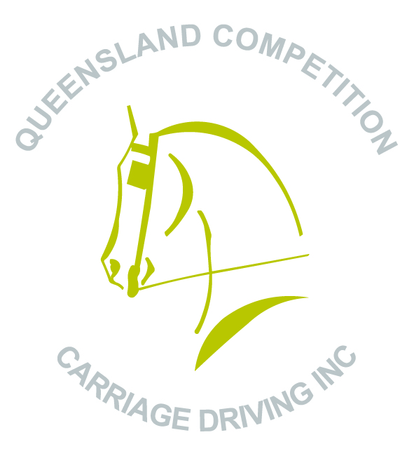

Queensland Carriage Carnival Interclub Challenge

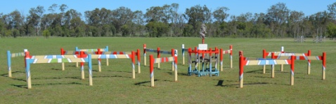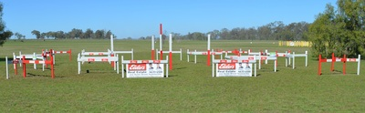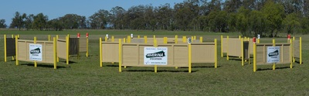

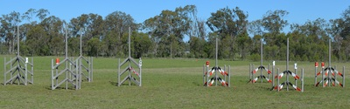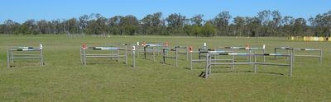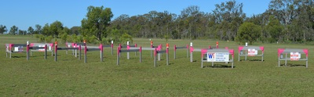

Sunday 6 May 2018

“Strongfield Stud”

440 Linthorpe Valley Road, Southbrook - QLD

Qld Carriage Carnival Interclub Challenge

- Drivers will drive the marathon obstacle challenge course once.
- The challenge will be run in sets of two Marathon Obstacles with recovery time allowed between each set. Each pair (set) of obstacles will be timed separately on the basis of the time in seconds taken to complete the course plus any penalties for faults converted to penalty seconds. (Basically, the fastest time with the least penalties wins).Overall winner will be the driver who drives all three sets of MO’s in the fastest time. Competitors will watch each other complete each set before moving on to the next set of obstacles. The order of the running list will be followed for each set.
- All gates of the Marathon Obstacles are minimum 3 metres wide
- Maps of the Marathon Obstacle course lettering will be provided and the course will be able to be walked from Saturday afternoon and before 8:30am on the morning of the competition. Event start time TBA.
- Marathon obstacle rules and penalties apply for the marathon obstacles
- Drivers are not required to carry whip in hand during the marathon challenge.
- Driver and groom (if applicable) must be wearing helmets and protective vest during the challenge.
- Grooms are able to talk to driver during the challenge in all classes.
- The following vehicle types are acceptable:
- 2 wheel and 4 wheel vehicles.
- Vehicles with pneumatic tyres and jogger type vehicles.

The safety and suitability of vehicles is competitors responsibility

Club Challenge:
- Each driver is to nominate which club team they are driving for as there will be an overall team winner for the competition as well.

Event Enquiries: Karyn Dillmann
Ph: 46910402 or 0431 515 224 qldcompetitioncarriagedriving@gmail.com

CLASSES

1 | Pony under 91 cm
2 | Pony 91cm and under 121cm
3 | Pony 121cm ne 149cm
4 | Horse over 149cm
5 | Pony Pairs 91cm ne 121cm
6 | Pony Pairs 121cm ne 149cm
7 | Horse Pairs over 149cm
8 | Pony Tandem 91cm ne 149cm
9 | Horse Tandem over 149cm
10 | Pony Team 91cm ne 149cm
11 | Horse Team over 149cm

** COMPETITORS DRIVING PONIES UNDER 127 CM (12.2HH) HAVE THE OPTION OF DRIVING WITHOUT A GROOM**

ENTRY FEES

Activity/Event | Fee for QCCD Inc. / EA member | Fee non-QCCD Inc. / EA member
Qld Carriage Carnival Interclub Challenge | $30 | $50

EVENT AND VENUE DETAILS

- Catering - Lunch and drinks will be available on site for a small fee.

- Camping and Facilities – There is plenty of camping space at Strongfield Stud and there are septic toilets and showers with warm water in the camping grounds. Camping is free.

- Yards–Competitors are welcome to bring their own yards. There are a number of day yards available for use. Competitors use yards at their own risk. Numbers are limited, so please indicate if you require the use of a yard on the entry form. There will be no extra fee for the use of yards.

- Water –Clean bore water is available for use and there are taps located near the yards and stables. Bring your own water containers for your horses.There is a concrete wash bay with a hose for washing horses. Fresh tank water is also available for human drinking water only.

- Dogs – Dogs are permitted with prior approval. Please contact Karyn to discuss

- Loading Ramp – An earth loading ramp is located near the camping ground to load/unload carriages and horses if needed.

CONDITIONS OF ENTRY

Drivers must be Qld Competition Carriage Driving Club Inc. members or EA members. A Restricted Membership form for this event must be completed for drivers who are not QCCD Inc. members or EA members. Restricted Membership is $20. Club Receipts or current Membership Cards (Club or EA) must be available for checking if required to receive Competitors Kits. Horses are not required to be registered with EA.
All competitors and their navigators/grooms compete at their own risk. The organising committee and land holders accept no responsibility for loss or damage to horses, owners, passengers, equipment, drivers, grooms or spectators, or any other person or property whatsoever, whilst at or near the venue, during the course of this event. All competitors, by entering this event, agree to be bound by this regulation.
All child/junior drivers between 12 and 18 years must be accompanied by a capable groom 18 years or over in all phases of the competition. Whenever a child/junior is in a vehicle they must be wearing an equestrian type helmet that complies with one of the three standards below and a back protector.
The organisers reserve the right to:
* Alter any advertised times;
* Refuse any entry, with or without stating the reason;
* Refuse admission to any person whose attendance may, in the opinion of the Organising Committee, impose a risk on the person, or to QCCD Inc. and EA members, or members of the public; or due to inappropriate behavior or failure to comply with the Club’s and EA expected standard of behavior;
* Measure any horse or pony upon discretion
* Reallocate a competitor to the appropriate class
Entry fees must accompany nominations.
The event will be run on time.
Organisers reserve the right to penalize competitors for unsafe practices.
Back protectors are required to be worn by grooms and drivers for this event.
The wearing of equestrian helmets complying with one of the three standards listed below and on the entry form is mandatory in the marathon and medical arm bands are recommended.
Equestrian helmets standards
- AS/NZS 3838,
- European Standard EN1384,
- United States Standard ASTN F1163
It is a condition of entry that competitors hand to the organisers a Horse Health Declaration Form on arrival before you receive your competitors kit.

ENTRY FORM

Queensland Competition Carriage Driving Inc.

“Strongfield Stud”- 440 Linthorpe Valley Road,
Southbrook – QLD

Sunday 6 May 2018
Entries Close Friday 27 April 2018

Driver Name:__________________________________________________

Age, if Jr. Driver: ______________________________________________

Address: _____________________________________________________

Phone: __________________________ Postcode: ____________________

Email: _______________________________________________________

QCCD Inc. Membership No. : __________________________________

EA Membership No. (if applicable): _______________________________

Note: If you are not a QCCD Inc. member you must supply an EA membership number or complete the restricted membership form for this event
Class | Pony/Horse Name | Height | Age | Fee | Yard required  (Y or N)
Camping | Yes or No
Name of Club ( team ) you are nominating to drive for:

Payment Methods:
Direct Deposit
Payment of entry fees can be made via Direct Deposit, using the following details.

Account Name: Qld Competition Carriage Driving Inc
Account Number: 03 755 5683
BSB: 084 983
Please use your name as the description/reference.

Email a scanned copy of this entry form with proof of payment to: qldcompetitioncarriagedriving@gmail.com

Cheque
Make cheque payable to: Qld Competition Carriage Driving Inc.
Post to:
Mrs Karyn Dillmann
440 Linthorpe Valley Road Southbrook 4363

Member Dangerous Activity Acknowledgement
Full Name of Participant (and of guardian if under 18 years)
Membership No. (QCCD Inc. No. or EA No.)
Postal Address
State ………………………………..Postcode Date of Birth
Name of Club/Organisation: Qld Competition Carriage Driving Inc.
Address of Event/Activity: Strongfield Stud, 440 Linthorpe Valley Road, Southbrook QLD 4363
Date of Event/Activity: 6 May 2018

In consideration for being permitted to participate in any way in horse sport activities, I, the undersigned, understand, acknowledge and accept that: Horse sports are a dangerous activity and horses can act in a sudden and unpredictable (changeable) way, especially if frightened or hurt. There is a significant risk that serious INJURY or DEATH may result from horse sport activities.

I understand and acknowledge the dangers associated with the consumption of alcohol or any mind altering drugs and agree not to drink alcohol or take drugs prohibited by law before or during any horse sports activities.

I agree to follow the directions of any event organiser or official and that any misconduct or refusal by me to follow any direction of any organiser or official can result in the CANCELLATION of my participation in the activities and my immediate removal from my horse NO MATTER where that may occur.

I agree to wear an approved helmet at all times whilst participating in the sport where this is required under the relevant EA and FEI rules and regulations.

I have had sufficient opportunity to read this Dangerous Activity Acknowledgement and fully understand its terms and sign it freely and voluntarily.

Dated: ___/___/___ Signature of driver

For Participants of Minority Age (Under Age 18)
This is to certify that I, as a parent/guardian with legal responsibility for this participant, acknowledge, understand and accept ALL OF THE ABOVE and consent and agree to my minor child's involvement or participation in horse sport activities. I also agree to abide by the Parents Code of Conduct as it relates to Equestrian Sports. I understand that should I breach this Code o Conduct in any way I may be penalised for such a breach as determined by Equestrian Queensland.

Dated: ___/___/___ Signature of guardian

I agree to abide by, and adhere to, the rules and by laws of EA, all conditions of entry and any other general information in the schedule.

Entry Form Checklist (circle Yes or No)

- Have you read the Conditions of Entry? Yes or No
- Do all the helmets that will be used (marathon and junior) in this event by the entry conform with at least one of the three standards listed below:
1. AS/NZS 3838
2. European Standard EN1384
3. United States Standard ASTN F1163 Yes or No
- Have you completed all sections of the Entry Form (including the Member Dangerous Activity Acknowledgement) Yes or No
- Have you enclosed a cheque for the entry? Yes or No
- Have you made payment via Direct Deposit for the entry? Yes or No
- Have you signed the Entry Form? Yes or No
- Have you completed the Restricted Membership Form if you are not a QCCD Inc. member or EA member? Yes or No

Restricted Membership Application Form
Queensland Competition Carriage Driving Inc.

To be completed by all non QCCD Inc. / non EA members only.

You must be a current financial member of Qld Competition carriage Driving Inc. EA or a Restricted Member if you wish to enter in this event/competition and be covered by EA insurance. Therefore, QCCD Inc. is offering a Restricted Membership which is valid for one event/competition only and must accompany the nomination/entry form and fees. Restricted membership does not entitle you to voting rights or cheaper nominations and is subject to endorsement by Warwick Club.

Restricted Membership for Activity/Event: Qld Carriage Carnival Interclub Challenge
Activity/Event Date: 6 May 2018
Activity Address: Strongfield Stud, 440 Linthorpe Valley Road, Southbrook QLD 4363

Cost per person: Included in event nomination fee/s (Restricted Members are to pay
non-QCCD Inc. / non EA member entry fees).

Restricted Member Details
Name:
Date of Birth:
Address:
Contact Number:
Email:
Emergency Contact:

I agree to abide by the Constitution and By-laws of Queensland Competition Carriage Driving Inc.

Signature: _________________________________________ Date: ________________
(if under 18 year, guardian please also sign)

Club Use Only
Signature
Approved: _______________________________ Date: ________________

