Equestrian Queensland Carriage Driving Clinic with Max Pearce

-EA/NCAS Level 2 Coach & Coach Educator

-EA Carriage Driving official

24 & 25
February 2018

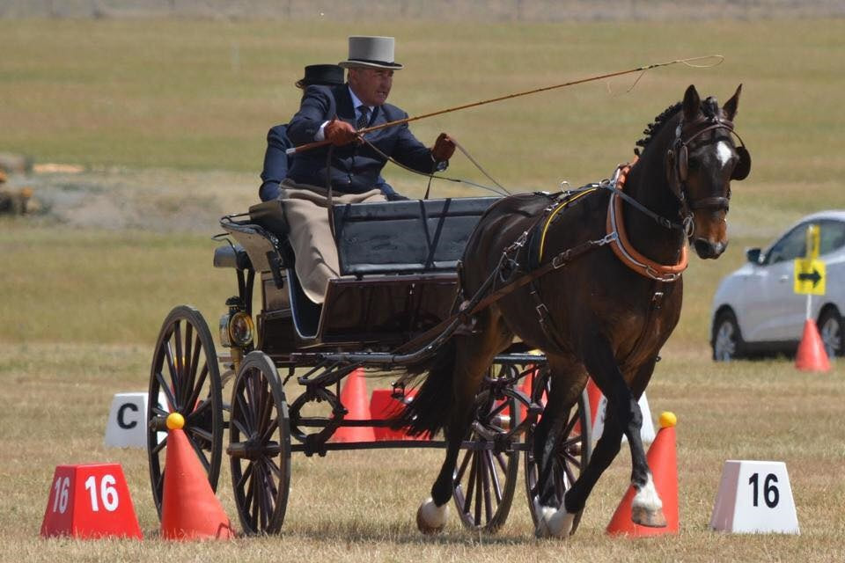

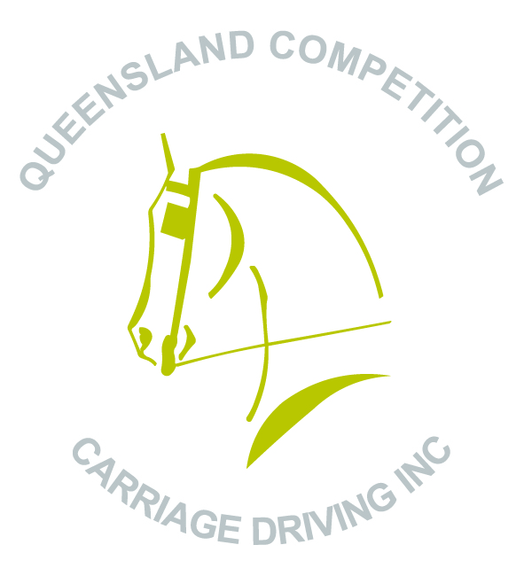

Hosted by:

Queensland Competition Carriage Driving Inc.

Venue: “Strongfield Stud”

440 Linthorpe Valley Road, Southbrook

Queensland Competition Carriage Driving Inc. wish to acknowledge Equestrian Queensland for endorsement and funding toward this activity.

Workshop Information

Carriage Driving Queensland, through Queensland Competition Carriage Driving Inc., is offering a follow up seminar and clinic for carriage drivers, volunteers, stewards, officials and potential officials on 24 & 25 February 2018 at ‘Strongfield Stud’ Southbrook to embed and build on learnings from our very successful Max Pearce Workshops in 2015, 2016 and 2017.

Once again, workshop facilitator for the weekend will be Max Pearce.

Content discussed over the weekend will relate to EA/FEI carriage driving (Combined Driving / Dressage / Cones) and will expand on the technical aspects and course design of competition carriage driving and training, and current FEI rule interpretations.

Carriage driving workshop will include:
- Developing and improving competition standard and performance ( Pre event preparation 2018 Hyfeed Winter Series / 2018 State Carriage Driving Championships)
- Dressage, Cones and Marathon driving – from the driver and officials perspective
The workshop will have a mix of group discussion and individual sessions. The days will start at 8am. Fence sitters are welcome and Max will be using a wireless microphone.

Venue : Strongfield Stud, 440 Linthorpe Valley Road, Southbrook (no dogs allowed without prior arrangement)
Camping and yards are available and people are welcome to camp Friday and Saturday night.
There is no power for camp sites.

Entry Fees:

Driving $70 per 40 minute lesson
Fence Sitting $10 (per day)
Camping and yards free

Direct Deposit
Account Name: Queensland Competition Carriage Driving Inc
Account Number: 03 755 5683
BSB: 084 983
Please use your name as the description/ reference.
Cheque
Payable to: Queensland Competition Carriage Driving Inc.
Post to: Karyn Dillmann (440 Linthorpe Valley Road, Southbrook 4363)

Conditions of Entry:
-Drivers must be QCCD Inc members or EA members. A restricted membership form ($20) for this event must be completed for drivers who are not QCCD Inc. members or EA members.
-All grooms who are not QCCD Inc. or EA members must complete dangerous activity acknowledgement form.
-All competitors and their navigators/grooms compete at their own risk. The organising committee and land holders accept no responsibility for loss or damage to horses, owners, passengers, equipment, drivers, grooms or spectators, or any other person or property whatsoever, whilst at or near the venue, during the course of this event. All competitors, by entering this event, agree to be bound by this regulation.

Equestrian helmets must be worn and comply with EA regulations.

It is a condition of entry that competitors hand to the organisers a Horse Health Declaration Form.

ENTRIES CLOSE: Friday 10 February 2018 – email your details and registration form to qldcompetitioncarriagedriving@gmail.com
The organising committee will make every effort to accommodate multiple lesson requests from drivers.
**Fence Sitters please advise your attendance as well for catering purposes. **

For further information please contact:
Karyn Dillmann Ph: (07) 4691 0402 or qldcompetitioncarriagedriving@gmail.com

Driver Name:__________________________________________________

Age, if Jr. Driver: ______________________________________________

Address: _____________________________________________________

Phone: _______________________________________________________

Email: _______________________________________________________

QCCD Inc. Membership No. : ____________________________________

EA Membership No. (if applicable): _______________________________

Note: If you are not a QCCD Inc. member you must supply an EA membership number
Saturday preference | Sunday preference | Pony/Horse Name | Fee  $70 per lesson | Fence sitting $10 per day | Camping  (Y or N) | Yard required  (Y or N)
 |  | TOTAL $

Restricted Membership Application Form

Queensland Competition Carriage Driving Inc.

You must be a current financial member of Queensland Competition Carriage Driving Inc., EA, or a Restricted Member if you wish to participate in this event and be covered by EA insurance. Therefore, Queensland Competition Carriage Driving Inc. is offering a Restricted Membership which is valid for one event/competition only and must accompany the nomination/entry form and fees. Restricted membership does not entitle you to voting rights or cheaper nominations and is subject to endorsement by Queensland Competition Carriage Driving Inc.

Restricted Membership for Activity/Event:
Activity/Event Date: Max Pearce Clinic 24 & 25 February 2018
Activity Address: Strongfield Stud, 440 Linthorpe Valley Road, Southbrook QLD 4363

Cost per person: $20.00

Restricted Member Details
Name:
Date of Birth:
Address:
Contact Number:
Email:
Emergency Contact:

I agree to abide by the Constitution and By-laws of Queensland Competition Carriage Driving Inc.

Signature: _________________________________________ Date: ________________
(if under 18 year, guardian please also sign)

Club Use Only

Approved: _______________________________ Date: ________________
Signature

Member Dangerous Activity Acknowledgement
Full Name of Participant (and of guardian if under 18 years)
Membership No. (QCCD Inc. or EA No.)
Postal Address
State ………………………………..Postcode Date of Birth
Name of Club/Organisation: Queensland Competition Carriage Driving Inc.
Address of Event/Activity:Strongfield Stud, 440 Linthorpe Valley Road, Southbrook QLD 4363
Date of Event/Activity:

In consideration for being permitted to participate in any way in horse sport activities, I, the undersigned, understand, acknowledge and accept that: Horse sports are a dangerous activity and horses can act in a sudden and unpredictable (changeable) way, especially if frightened or hurt. There is a significant risk that serious INJURY or DEATH may result from horse sport activities.

I understand and acknowledge the dangers associated with the consumption of alcohol or any mind altering drugs and agree not to drink alcohol or take drugs prohibited by law before or during any horse sports activities.

I agree to follow the directions of any event organiser or official and that any misconduct or refusal by me to follow any direction of any organiser or official can result in the CANCELLATION of my participation in the activities and my immediate removal from my horse NO MATTER where that may occur.

I agree to wear an approved helmet at all times whilst participating in the sport where this is required under the relevant EA and FEI rules and regulations.

I have had sufficient opportunity to read this Dangerous Activity Acknowledgement and fully understand its terms and sign it freely and voluntarily.

Dated: ___/___/___ Signature of driver

For Participants of Minority Age (Under Age 18)
This is to certify that I, as a parent/guardian with legal responsibility for this participant, acknowledge, understand and accept ALL OF THE ABOVE and consent and agree to my minor child's involvement or participation in horse sport activities. I also agree to abide by the Parents Code of Conduct as it relates to Equestrian Sports. I understand that should I breach this Code o Conduct in any way I may be penalised for such a breach as determined by Equestrian Queensland.

Dated: ___/___/___ Signature of guardian

